HEADER STRUCTURE

Left Section
Logo: INNOMEDIA
Guidelines:
- Clean design
- Bold typography
- No tagline (keep header minimal)

Center / Right Section
Navigation Menu:
- Home
- Services
- Work (or Portfolio)
- Process
- About (optional for one-page layout)
- Contact

Right Section (CTA Button)
Primary Call-To-Action:
- Let’s Talk
or
- Get Started

Final Header Layout
INNOMEDIA | Home | Services | Work | Process | Contact | [Let’s Talk]

HERO SECTION

INNOMEDIA

Click. Convert. Repeat.
Strategy. Creativity. Performance.
We build digital systems that turn attention into action and ideas into measurable growth.
Blending creative thinking with performance-driven execution, we help brands stand out, scale faster, and convert better.
Every solution is designed with clarity, precision, and real business impact in mind.

THE INNO FRAMEWORK

I — Innovation
Creative thinking powered by modern digital tools and technology.

N — Navigation
Strategic direction that guides brands toward sustainable growth.

N — Network
Building strong digital connections between brands and audiences.

O — Optimization
Continuous improvement through data insights and performance analysis.

About Innomedia

Creativity at the Core. Performance in Every Move.
At Innomedia, we believe digital growth is not just about being visible — it’s about being effective.
What sets us apart is our ability to blend strategy, creativity, and performance into one unified system. Our team works with clarity, speed, and precision to build solutions that are not only visually strong but result-driven.
We don’t follow a fixed formula. Every brand we work with is approached with a fresh perspective, tailored strategy, and a focus on measurable outcomes.
From building identities to scaling campaigns, our goal is simple —
to help businesses grow smarter, faster, and stronger in the digital space.\

OUR EXPERTISE
Delivering creative, strategic, and performance-driven digital solutions.

Graphic Design & Visual Branding
Building visual identities that define how your brand is seen and remembered.

Website & E-commerce Development
Creating fast, responsive websites designed to engage users and drive conversions.

CGI & VFX Video Production
Producing high-impact visuals that elevate storytelling and product experience.

Social Media Marketing
Growing your brand presence through strategic content and audience engagement.

Search Engine Optimization (SEO)
Improving visibility on search engines to drive consistent organic growth.

Wikipedia & IMDb Creation
Developing structured profiles that enhance credibility and digital authority.

Copywriting & Content Writing
Crafting clear, persuasive content that connects and converts.

Content Strategy & Development
Planning content that supports branding, engagement, and long-term growth.

Video Production & Editing
Creating professional videos designed for marketing and communication.

2D & 3D Motion Graphics
Designing dynamic visuals that simplify ideas and capture attention.

UI/UX Design & Wireframing
Building user-focused designs that improve experience and usability.

Custom Software & Application Development
Developing tailored solutions that support business operations and scalability.

Digital Marketing Services
Executing strategies that strengthen brand visibility and digital presence.

Performance Ads Management
Running data-driven campaigns focused on leads, conversions, and ROI.

OUR PROCESS

Simple. Structured. Result-Oriented.

OUR IMPACT

The results we’ve built while growing brands together.

RESULTS & IMPACT
1350+ Clients Served
250+ Projects Completed
400+ Campaigns Managed
15+ Years of Industry Experience

OURCLIENTS

Some friends we have made while working together.
(client logo )

Testimonials

Trusted by happy people

1️⃣
“Innomedia didn’t just give ideas, they actually helped us execute things properly. The overall workflow became much smoother after working with them.”
— Rohit Patel
(Real Estate Consultant)

2️⃣
“Initially we were unsure, but the way they handled everything from design to marketing was quite structured. The results improved gradually and consistently.”
— Neha Shah
(E-commerce Business Owner)

3️⃣
“What I liked most is that they don’t overpromise. They explain clearly what will work and then focus on delivering that.”
— Amit Verma
(Business Owner)

4️⃣ (Optional)
“The team is easy to communicate with and quite responsive. Work was delivered on time and without unnecessary complications.”
— Karan Mehta
(Startup Founder)

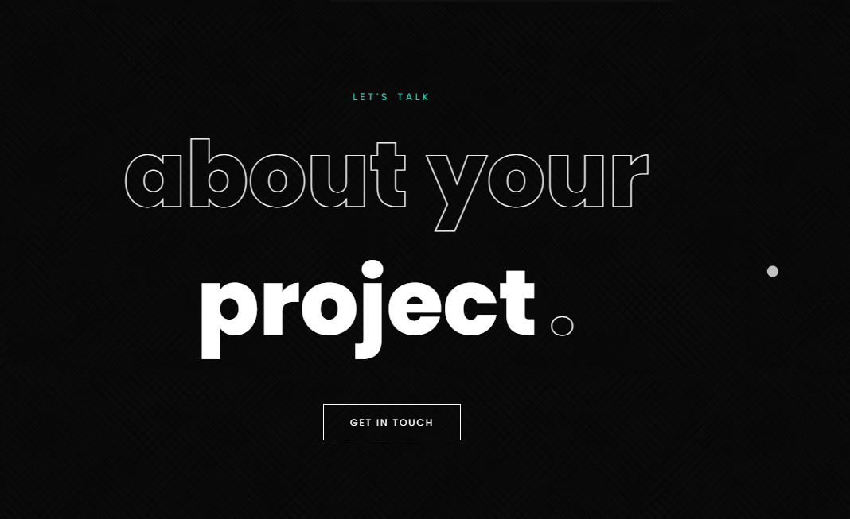same way contanct should be done
FINAL FOOTER CONTENT (INNOMEDIA)

COLUMN 1 — BRAND

INNOMEDIA
Innomedia is a digital marketing company focused on building scalable, performance-driven brands through strategy, creativity, and technology.
We create digital systems designed to deliver visibility, engagement, and real business growth.

COLUMN 2 — QUICK LINKS

Quick Links
Home
About
Services
Work
Process
Contact

COLUMN 3 — SERVICES

Services
Social Media Marketing
Performance Ads Management
Website Development
Branding & Design
SEO
Content & Video Production

COLUMN 4 — CONTACT / VISIT

Get in Touch
Ahmedabad, Gujarat, India
+91 9998980606
connect.innomedia@gmail.com

🔻 BOTTOM STRIP

Social Links
Facebook | Instagram | LinkedIn

Legal
Privacy Policy | Terms & Conditions

Copyright
© 2026 Innomedia. All rights reserved.
Built with clarity, creativity, and performance.

💡 DESIGN STRUCTURE
👉 4 Columns:
| Brand | Links | Services | Contact |
👉 Bottom:
- Left → Social + Legal
- Right → Copyright

